2 types of inference:

1. Estimating statistic parameter, like the mean. We use the X – sample mean as an estimet for the population mean with stderr = std/sqrt(n)

* We use normal properties to find the confidence interval.

1. Hypothesis Testing

Hypothesis Testing - Basic terminology

* **Unknown population parameter (e.g., μ)**

Page 243

* **Alternative Hypothesis: H1**

1’st theory - The research hypothesis – Mean < X0 (treatment decrease fatigue)

Examples:

* Research theory
* Proof that a defendant is guilty
* **Null hypothesis: H0**

2’nd theory – the negation of the research - Null hypothsis Mean = X0 (no change in fatigue)

* **One-sided / two-sided alternative**
* **Statistical Test**

1. Research hypothesis (also called the alternative hypothesis), denoted by Ha.

*Ha*: m > 3

1. Null hypothesis, denoted by H0

*H*0: m ≤ 3

1. **Test statistics**, denoted by T.S.

Quantity computed from sample in order to support research hypothesis

For sample mean = 3.3 we have,

T.S.: *Z = (X – m)/(σ/√n) = (3.26-3)/(0.5/√16) = 0.26*8 = 2.08*

1. **Rejection region**, denoted by R.R.

The rejection region contains the values of y that support the research hypothesis and contradict the null hypothesis;

Page 244

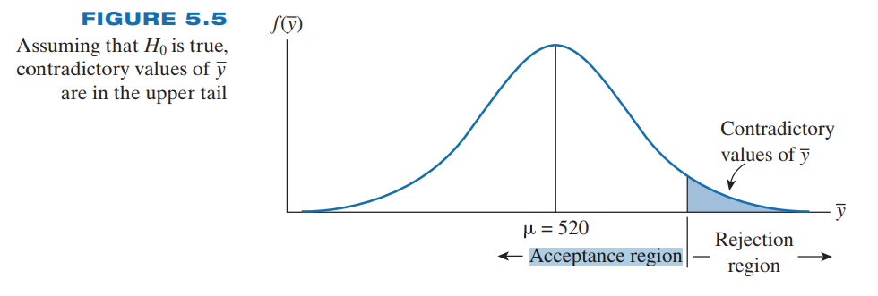

For α =0 .01 and a right-tailed test, we reject *H*0 if Z *≥ Z0.01*,  
where *Z0.01 =* 2.33 (one sided)

1. Check assumptions and draw conclusions.

Because the observed value of *z*, 2.08, do not exceed 2.33, we might be tempted to accept the null hypothesis that m = 3. The only problem with this conclusion is that we do not know **β**, the probability of incorrectly accepting the null hypothesis.

**Guidelines:**

To evaluate the research hypothesis, we take the information in the sample  
data and attempt to determine whether the data support the research hypothesis or  
the null hypothesis, but we will give the benefit of the doubt to the null hypothesis

**2 types of error:**

* **Probability of Type I error, α**

reject the null hypothesis when it is true or P(H1/H0)

* **Probability of Type II error, β** or P(H0/H1)

accept the null hypothesis when it is false and the research hypothesis is true

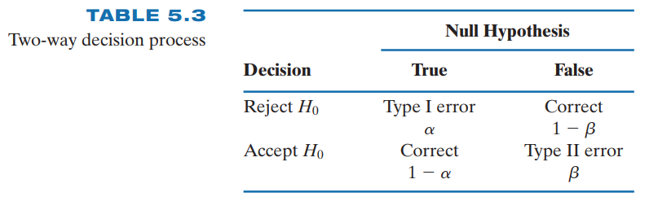

**Computing α**

Page 245

in statistics: the experimenter specifies a tolerable probability for a Type I error of the statistical test. Thus, the experimenter may choose a to be .01, .05, .10, and so on. Specification of a value for a then locates the rejection region. Determination of the associated probability of a Type II error is more complicated and will be delayed until later in the chapter.

**Computing β**

Page 250

* **Power**

Page 250

In engineering – we construct ROC curve (type 1 vs type 2 curve) – the area under to ROC curve indicate the quality or usfulness of the statistical test (sample)

Another way is to use cost functions

* **p value**

